STAT 112 - Introduction to Data Processing and Visualization Tableau Project Part-1

by
Kemal Can Yoloğlu
(2614915)

Data introduction

Firstly, we had 2 different datasets and we have joined these datasets in Tableau to use more efficiently. Then we have 18 data which came from that situation (18 fields and 3900 rows.). Our story is I have an online shopping platform and I want to analyze these data for make more profit and develop my company. We have:

data name data type

- Customer ID Numeric
- Age Numeric
- Gender Categorical
- Item.Purchased Categorical
- Category Categorical
- Purcahse.Amount..USD Numeric
- Location Categorical
- Size Categorical
- Color Categorical
- Season Categorical
- Review.Rating Numerical
- Subscription.Status Categorical
- Shipping.Type Categorical
- Discount.Applied Categorical
- Promo.Code.Used Categorical
- Previous.Purchases Numerical
- Payment.Method Categorical
- Frequency.of.Purchases Numerical

Data Preprocessing

I did not use any different tool from Tableau to clean data but when I looked at data carefully I realized that Discount.Applied and Promo.Code.Used data are exactly same. Also in Frequency.of.Purchases data there are 2 kind of words which are exactly same meaning: Quarterly and Every 3 Months.

- Firstly I hid Promo.Code.Used then I created a calculated field which replaces Quarterly to Every 3 Months in Frequency.of.Purchases.
(REPLACE([Frequency.of.Purchases], "Quarterly", "Every 3 Months")
- Additionally, I changed Location’ s data type by clicking Geographic Role – State/Province.
- Finally, for our goal, I wanted to analyze Previous.Purchases and Purchase.Amount..USD together to draw conclusion clearly. Therefore, I created another calculated field which is Final Money.
([Previous.Purchases] * [Purchase.Amount..USD])

Exploratory Data Analysis

As I’ve mentioned I have an Online Shopping Platform and I wanted to analyze some data. After those steps, I want to go further to make more money but for that desire I believe that asking some questions makes my desire easier. Here my questions and appropriate visualization techniques with interpretations:

- Which location makes more money?

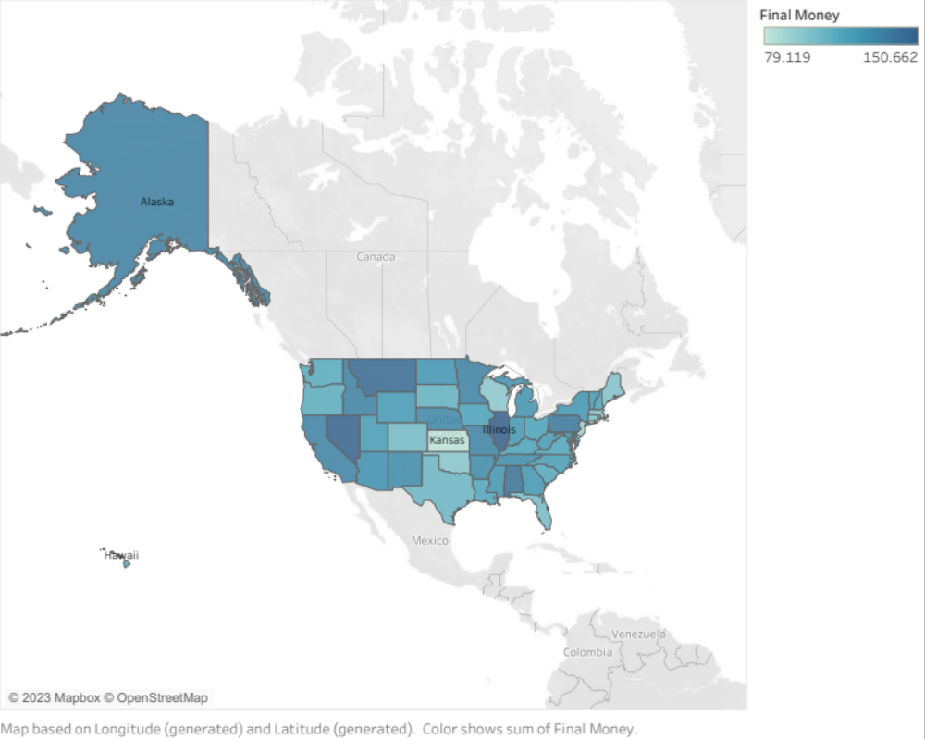

For answering that question I use final money data I created. Based on the map above, I can say that money nearly differs from state by state. First state is Illinois and it gives $150.662 and last state is Kansas with $79.119. Also our total income is $5.919.20.

- What is the relationship between shipping type, previous purchasing, subscription status and final money?

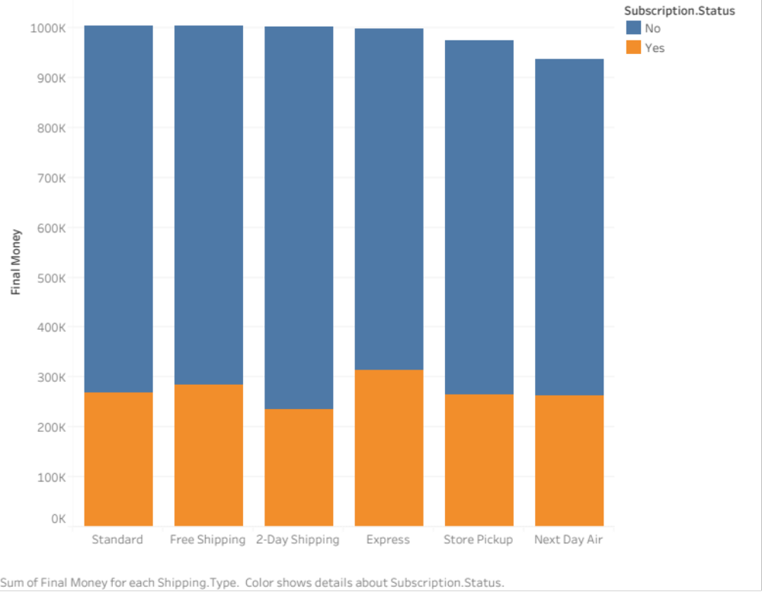

Here I want to analyze about 2 dimensions and 2 measures which are Subscription.Status, Shipping.Type and Final Money, Previous.Purchases. I want to start with subscription status. Our company has less subscriber, most of our customers are no subscriber and we earn lots of money by them. Also, their previous purchases are more than subscriber ones. Our company should make them subscribe and regular customer. We are large enough to sell our products to every state in U.S so we have to make good arrangements with shipping companies and also give free shipping opportunities for our subscribers. So that they become regular customers.

Here this graph says that our shipping types and gaining money are like each other but Next Day Air shipping is the less part of that. We generally sent cargos by air to Alaska and Hawaii (I assumed that information by leaning on my story). By looking at the first question’s graph we can conclude that Alaska is making money above the average which is $114,89 and Hawaii is $112,007. So that they are important for us. By that conclusion we should consider carefully and clearly that shipping. Maybe its cost is too much. For earning more customers and convert them to subscriber, we have to take some risks and give some opportunities to prefer our company.

- Which season makes more money?

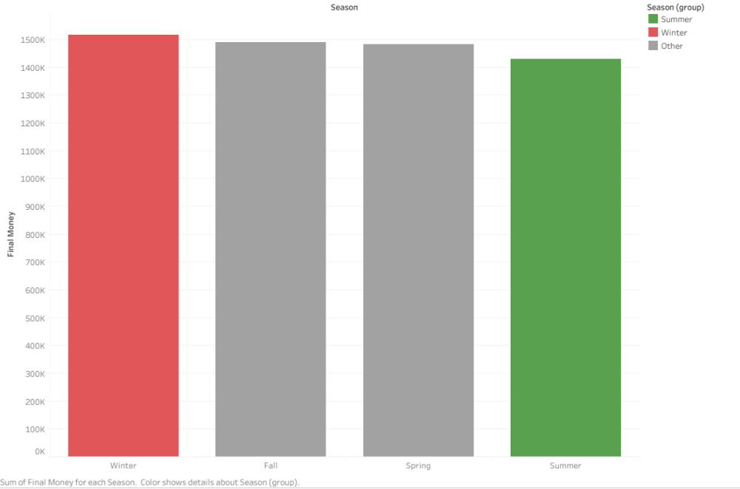

By looking at that visualization, I can say that we are selling our products similarly by seasons. Winter is the most part with $1.517.469 and summer is the least part with $1.429.054 . Why so? There could be many different factors but I want to take two of them such that customers’ shopping behavior in summer seasons and our summer type of products maybe not enough to be chosen by customers. For the first reason Finn et al. (2010)* stated that "Research in psychology has demonstrated that weather has an impact on an individual's mood. Various meteorological factors such as temperature, humidity, wind speed, sunlight hours, barometric pressure, and precipitation were found to influence mood ratings. For instance, higher barometric pressure and increased sunlight had the strongest effect on mood. Studies indicate that low humidity levels, abundant sunlight, high barometric pressure, and warmer temperatures are associated with positive moods. Exposure to sunlight specifically contributes to the production of serotonin in the brain, improving mood and reducing negative affect. Studies on consumer behavior suggest that individuals in positive moods tend to evaluate products more favorably and are inclined to spend more. Positive atmospheres in stores have been linked to improved consumer moods, resulting in increased spending. Furthermore, research demonstrates that negative affect mediates the relationship between sunlight and consumer behavior, influencing spending decisions." By their states we can think that in summers people mostly prefer buying products in real shops. For second reason I can say that our company allows the path which makes quality products and for that situation maybe we should change some strategies about summer products.

- Which age group makes more money?

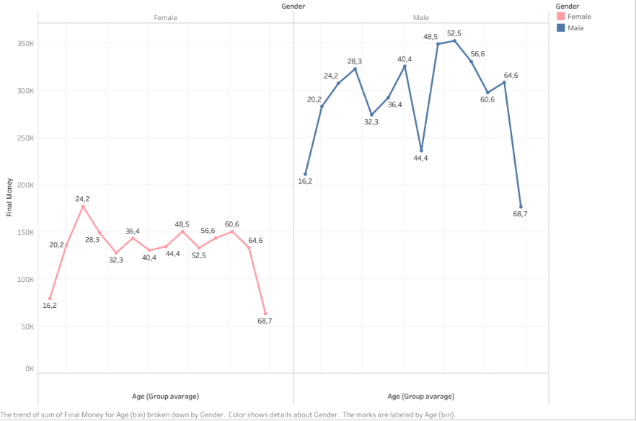

The graph above shows our company’s customers gender type and average ages. Our customers are generally males and their maximum age with respect to Final Money is 52,5 on the other hand female customers are younger again with respect to Final Money. Why so? Maybe our products are not suitable for young mans. Hence, we have to make another strategy to earn them. Also male customers’ average age differs too much than females. For male part, our company has to make good strategy. For example, we can produce younger products and maybe we can make special sale for students or specific age group people to collect them. Additionally, we can make them subscriber for other special sales. It becomes perfect!

- Which payment method most preferred?

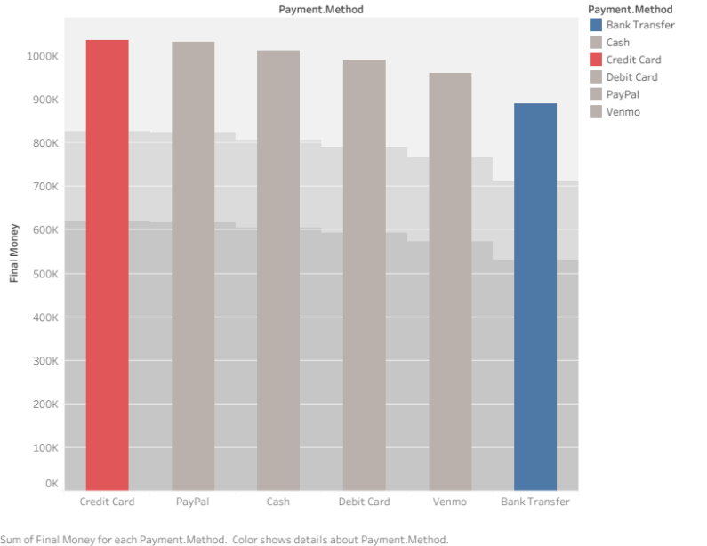
Firstly, we have to consider bank’s fee. For that situation we need to make special arrangements with specific banks which are more common by customers. Also we should consider cash payment. It is very good among those payment methods. To make more money and give less fee to banks we can make special sale for cash payment for a while. Until we make them to habit and at that time we can make arrangements with most common payment method’s banks.

- Which category makes more money?

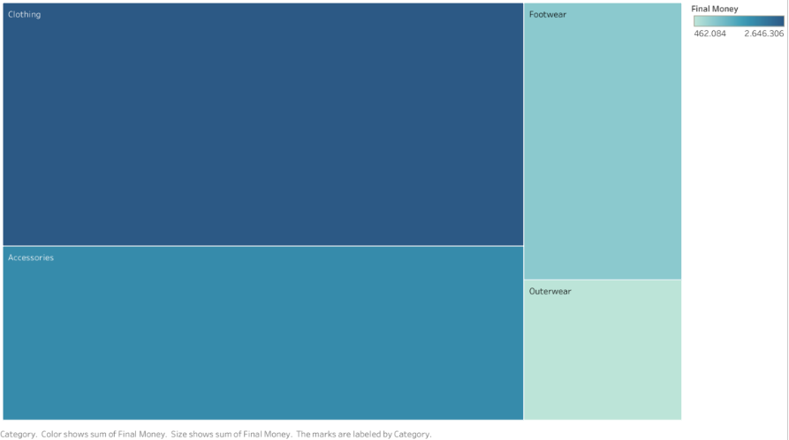
Here, we can state that our customers like to buy clothes than accessories and others. For this situation, we need to focus more footwear and outwear products. For doing that we should develop our system. For instance, we can make more quality products rather than other companies. It is strange that clothes category is the first one and outwear category is the last one. Maybe our outwear products are more expensive than others. We need to do market searching for that and make firm steps.

- Which top clothing item has more review rating by top 5 preferred colors?

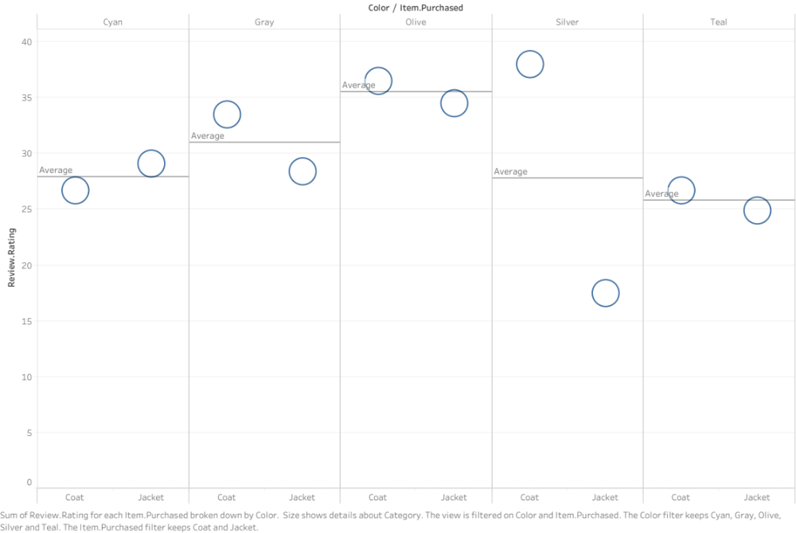

After the last question, I want to look at customers review according to outwear items and 5 colors which are most preferred. (For preferences I look at the previous purchased with colors.) Also, I would like to clear a point that I want to look at outwear items to draw conclusion about “Why outwear category is less preferred? ” So, it can be seen in top 5 colors are like each other except silver color. Maybe silver color outwears products make some trouble about its color or something else. We need to know that. To do that we can ask customers or read customers’ reviews about products. Also we should look at another 5-color group which comes after these colors. Why are we looking at colors? Because I believe that by looking color by color makes our conclusion more easily and clearly. It becomes easier because we go further step by step and we can analyze easily by looking products reviews color by color.
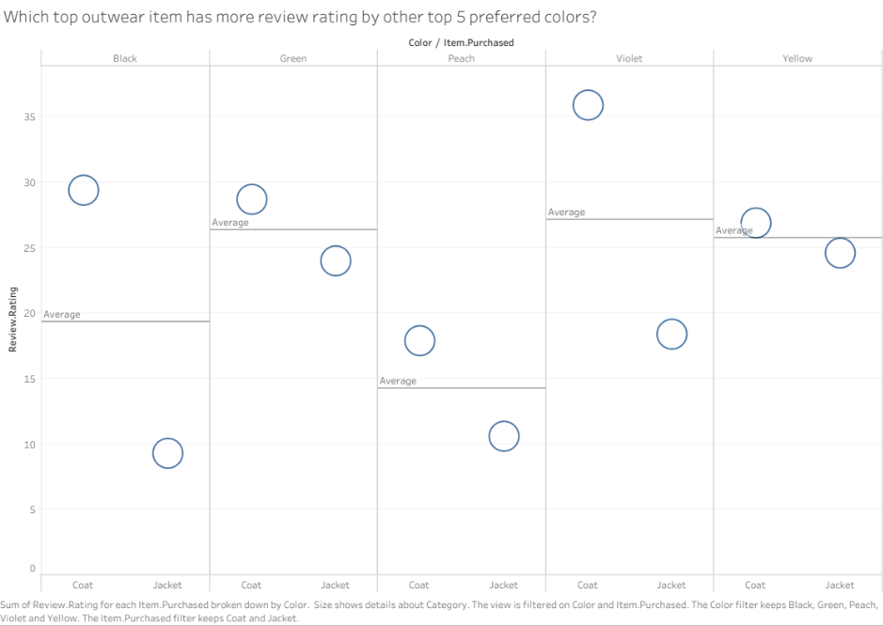

Here, we have other top 5 colors’ graph. We can say that these time black and violet colors are problematic. We need to solve that problem.

- Which top clothing item makes more money in top 10 states for purchasing in U.S ?

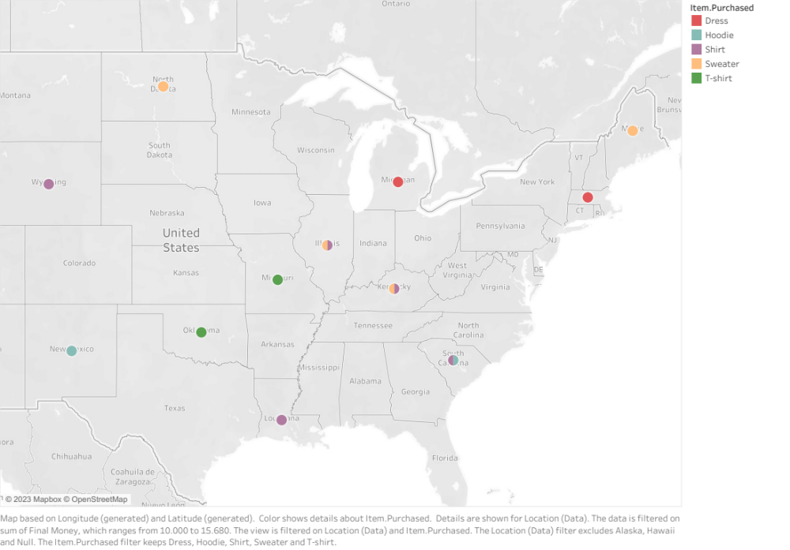
Here, I want to look at the perfectible part of our company. I looked at the $10.000 to $15.680 for top clothing items such as dress, hoodie, shirt, sweater, and t-shirt. Also I want to look at the top 10 locations of that products. For Illinois (Because that place is number one for final money) they prefer sweater and t-shirt. We can ask them “Why they love our products?” By finding that question’s answer we can go further on that strategy. On the other hand they are most part of our customers so they do not tell lie thoughts. We can deal with problems that they tell us to be fixed. After that, our company makes more profit.

- Which season makes more money for top 5 colors by purchasing amounts ?

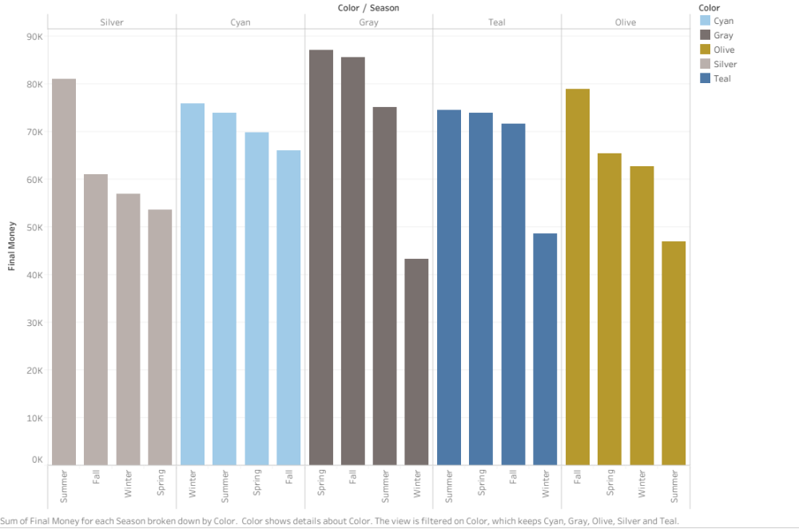

Here, I want to look again colors but this time with season and final money. By looking at the graph above we can say that in summer we are good at silver color products but in the question 7 we said that silver color’s reviews are differ for outwears. Probably outwears does not preferred in summers but when we look at winter for same color it became last second for making money. Also we can look at the gray color in winter. Is not it too less? Gray color can be preferred n winters. Maybe it is problematic. We can go further that question by analyzing another graphs.

Conclusion and Discussion

In conclusion, throughout our project on the interpretations and questionings on the tidied and cleaned data, I have seen that looking much more graphs and data allows us to draw conclusion clearly. For example question 9 and 7. I realized that when I wrote this report at same time. Generally our company is large enough to sell products among the U.S states and there are some fixable issues. Hopefully, all of them have solutions for their problems as I have mentioned. To draw conclusion clearly I have tried to focus several things that may be lead us to lose money or earning less money. By looking that report our company can be make lots of profit…

References:

*Finn, Murray & Popkowski Leszczyc (2010). The Effect of weather on consumer spending. https://www.researchgate.net/publication/222825354_The_Effect_of_weather_on_consumer_spending

https://public.tableau.com/app/profile/kemal.can.yolo.lu/viz/Project_17022311521900/Whichdirectionshouldbegoneformakingmoremoney?publish=yes

